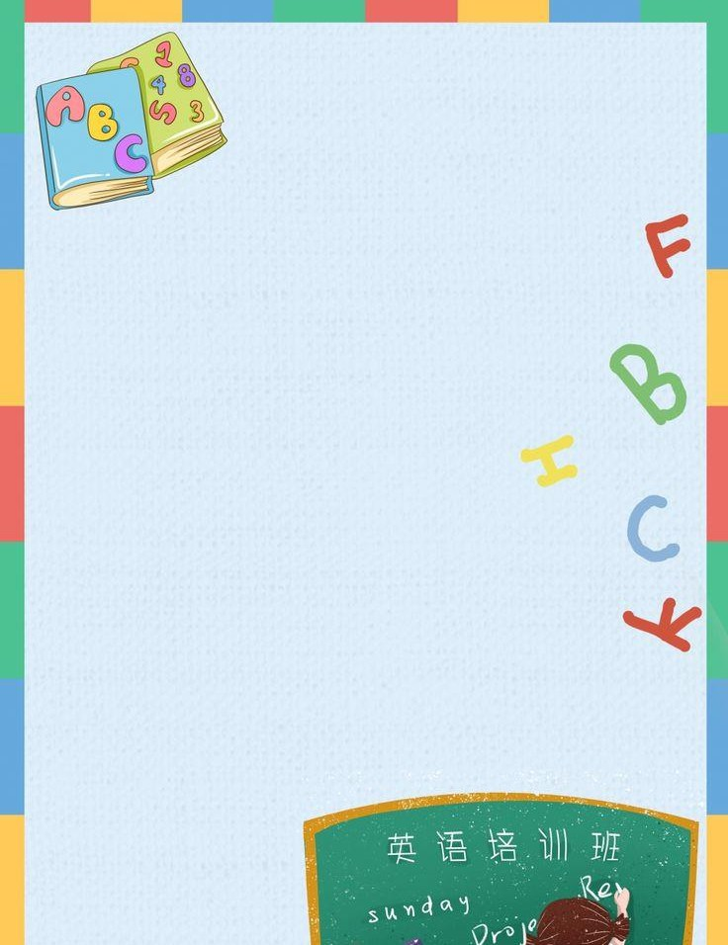

Listening Audios Extra

[Nivel 1 4to Parcial Kids](https://nahidamika.github.io/assets/misc/TEST%20KIDS/EXTRAORDINARY%20TEST%20KIDS/Kids%201/OPW4%20Test%20PARTIAL%202.mp3)

[Nivel 2 4to Parcial Kids](https://nahidamika.github.io/assets/misc/TEST%20KIDS/EXTRAORDINARY%20TEST%20KIDS/Kids%202/OPW5%20Test%20PARTIAL%202.mp3)

[Nivel 3 4to Parcial Kids](https://nahidamika.github.io/assets/misc/TEST%20KIDS/EXTRAORDINARY%20TEST%20KIDS/Kids%203/ShineOnPlus1_114.mp3) **114**

[Nivel 3 4to Parcial Kids](https://nahidamika.github.io/assets/misc/TEST%20KIDS/EXTRAORDINARY%20TEST%20KIDS/Kids%203/ShineOnPlus1_115.mp3) **115** [Nivel 3 4to Parcial Kids](https://nahidamika.github.io/assets/misc/TEST%20KIDS/EXTRAORDINARY%20TEST%20KIDS/Kids%203/ShineOnPlus1_116.mp3) **116**

[Nivel 3 4to Parcial Kids](https://nahidamika.github.io/assets/misc/TEST%20KIDS/EXTRAORDINARY%20TEST%20KIDS/Kids%203/ShineOnPlus1_117.mp3) **117**

[Nivel 4 4to Parcial Kids](https://nahidamika.github.io/assets/misc/TEST%20KIDS/EXTRAORDINARY%20TEST%20KIDS/Kids%204/ShineOnPlus2_126.mp3) 126

[Nivel 4 4to Parcial Kids](https://nahidamika.github.io/assets/misc/TEST%20KIDS/EXTRAORDINARY%20TEST%20KIDS/Kids%204/ShineOnPlus2_127.mp3) 127

[Nivel 4 4to Parcial Kids](https://nahidamika.github.io/assets/misc/TEST%20KIDS/EXTRAORDINARY%20TEST%20KIDS/Kids%204/ShineOnPlus2_128.mp3) 128

[Nivel 4 4to Parcial Kids](https://nahidamika.github.io/assets/misc/TEST%20KIDS/EXTRAORDINARY%20TEST%20KIDS/Kids%204/ShineOnPlus2_129.mp3) 129

[Nivel 5 4to Parcial Kids](https://nahidamika.github.io/assets/misc/TEST%20KIDS/EXTRAORDINARY%20TEST%20KIDS/Kids%205/ShineOnPlus3_122.mp3) **122**

[Nivel 5 4to Parcial Kids](https://nahidamika.github.io/assets/misc/TEST%20KIDS/EXTRAORDINARY%20TEST%20KIDS/Kids%205/ShineOnPlus3_123.mp3) **123**

[Nivel 5 4to Parcial Kids](https://nahidamika.github.io/assets/misc/TEST%20KIDS/EXTRAORDINARY%20TEST%20KIDS/Kids%205/ShineOnPlus3_124.mp3) **124**

[Nivel 5 4to Parcial Kids](https://nahidamika.github.io/assets/misc/TEST%20KIDS/EXTRAORDINARY%20TEST%20KIDS/Kids%205/ShineOnPlus3_125.mp3) **125**

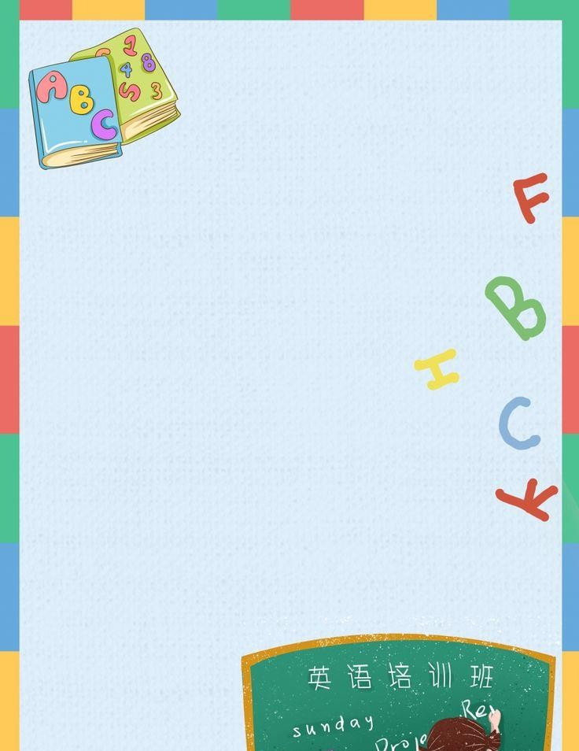

[Nivel 6 4to Parcial Kids](https://nahidamika.github.io/assets/misc/TEST%20KIDS/EXTRAORDINARY%20TEST%20KIDS/Kids%206/ShineOnPlus4_124.mp3) **124**

[Nivel 6 4to Parcial Kids](https://nahidamika.github.io/assets/misc/TEST%20KIDS/EXTRAORDINARY%20TEST%20KIDS/Kids%206/ShineOnPlus4_125.mp3) **125**

[Nivel 7 4to Parcial Kids](https://nahidamika.github.io/assets/misc/TEST%20KIDS/EXTRAORDINARY%20TEST%20KIDS/Kids%207/ShineOnPlus5_122.mp3) **122**

[Nivel 7 4to Parcial Kids](https://nahidamika.github.io/assets/misc/TEST%20KIDS/EXTRAORDINARY%20TEST%20KIDS/Kids%207/ShineOnPlus5_123.mp3) **123**

[Nivel 8 4to Parcial Kids](https://nahidamika.github.io/assets/misc/TEST%20KIDS/EXTRAORDINARY%20TEST%20KIDS/Kids%208/ShineOnPlus6_127.mp3) **127**

[Nivel 8 4to Parcial Kids](https://nahidamika.github.io/assets/misc/TEST%20KIDS/EXTRAORDINARY%20TEST%20KIDS/Kids%208/ShineOnPlus6_128.mp3) **128**

[Nivel 9 4to Parcial Kids](https://nahidamika.github.io/assets/misc/TEST%20KIDS/EXTRAORDINARY%20TEST%20KIDS/Kids%209/beehive_american_5_tests_01.mp3)

[Nivel 10 4to Parcial Kids](https://nahidamika.github.io/assets/misc/TEST%20KIDS/EXTRAORDINARY%20TEST%20KIDS/Kids%2010/beehive_american_6_tests_01.mp3)